**Development of an AI-Enhanced Water Intake Monitoring Application**

**Abstract**

Maintaining adequate hydration is critical for physiological well-being, yet consistent manual tracking of water intake is often challenging. This paper introduces the design, development, and potential utility of an AI-powered water intake monitoring system. The proposed system uses a web-based architecture with a FastAPI backend for robust data management, integrates Langchain and Large Language Models (LLMs) like Google's Gemini models for personalized feedback, and employs a Streamlit frontend for intuitive user interaction and data visualization. The objective is to provide users with an effortless method for logging their daily water consumption, accessing historical intake data, and receiving actionable, AI-driven insights to improve hydration habits.

**Keywords**: Artificial Intelligence, Large Language Models, Water Intake Tracking, Personalized Feedback, FastAPI, Langchain, Streamlit, Health Monitoring.

**1. Introduction**

Water is vital for various bodily functions, yet many people struggle to meet the recommended daily intake. Traditional water tracking approaches, such as manual record-keeping or simple reminder applications, fail to provide personalized feedback and sustained user engagement. This research aims to bridge that gap by developing an AI-driven application that not only tracks water consumption but also delivers context-aware recommendations. The core objectives include:

* Establishing a robust backend infrastructure for efficient data storage and retrieval.
* Leveraging AI models, specifically Google's Gemini models via Langchain, to generate personalized hydration recommendations.
* Presenting this information through a user-friendly interface for improved engagement and behavior modification.

This study contributes to the growing field of AI-based personal health tools, demonstrating the potential of integrating language models to promote healthier lifestyle choices.

**2. Literature Review and Motivation**

Current water tracking applications vary from basic counters to more advanced tools that offer simple reminders. However, few effectively incorporate Artificial Intelligence to analyze individual hydration patterns and offer personalized feedback. This paper seeks to fill that gap by integrating advanced AI models like Google's Gemini into a comprehensive water intake management system. Prior research in AI-driven health interventions, such as in dietary management and exercise adherence, has demonstrated promising results, suggesting that similar approaches could be effective in hydration management.

**3. Methodology and System Architecture**

The application adopts a modular, scalable architecture comprising the following components:

**3.1 Backend Development**

The backend is built using **FastAPI**, a high-performance Python web framework. FastAPI serves as the central hub for managing API requests originating from the frontend. Key backend functions include:

* Logging new water intake entries.
* Retrieving historical water intake data.
* Interfacing with the AI module to generate personalized feedback.

**3.2 Database Management**

An **SQLite** database is used in the initial prototype due to its simplicity and file-based nature. The database schema consists of a water_log table with the following attributes:

* id: A unique identifier for each log entry.
* timestamp: The exact date and time of water consumption.
* amount_ml: The quantity of water consumed (in milliliters).

**3.3 Artificial Intelligence Integration**

AI capabilities are integrated using **Langchain**, a framework designed for building applications powered by LLMs. Langchain facilitates interaction with Google's **Gemini models**. The AI workflow includes:

* **Prompt Engineering**: Prompts guide the LLM in generating relevant feedback based on the user's water intake.
* **Personalized Feedback Generation**: The LLM processes the input data and generates tailored suggestions or motivational messages aimed at improving hydration habits.

**3.4 Frontend Development**

The user interface is developed using **Streamlit**, a Python library for creating interactive applications. The frontend includes:

* **Water Intake Logging**: Easy user input of water consumption.
* **Historical Data Visualization**: Dashboards displaying intake summaries.
* **Hydration Pattern Visualization**: Graphical representations such as line and bar charts.
* **AI-Generated Feedback**: A section that shows personalized AI feedback.

**Figure 1: System Architecture Diagram**

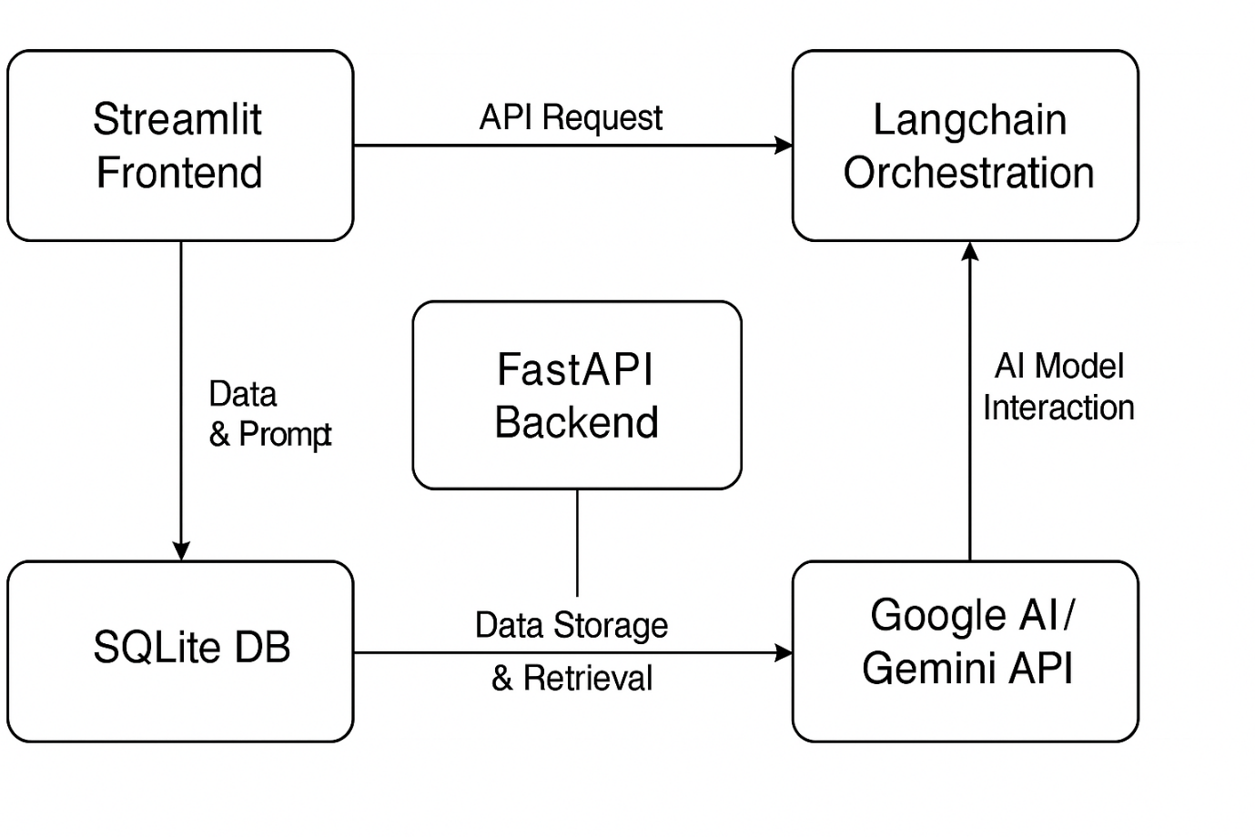  
**Figure 1** illustrates the interaction between the frontend (Streamlit), the backend (FastAPI), Langchain orchestration, and the underlying database and AI services.

**4. Implementation Highlights**

**API Endpoint Definition**

* POST /log: Accepts data containing the timestamp and amount of water consumed and stores it in the database.
* GET /history: Retrieves historical water intake logs.
* GET /feedback: Retrieves recent user data, interacts with Langchain/Gemini, and returns personalized feedback.

**Database Schema Creation**

The water_log table in the SQLite database is defined with appropriate data types: INTEGER for id and amount_ml, TEXT or DATETIME for timestamp.

**Langchain Prompt Engineering**

Prompts are structured to ensure clear, concise, and actionable feedback. For example:

"Analyze the following water intake log for the past 24 hours: [{data}]. Provide a brief, encouraging message and one actionable tip to help the user maintain or improve their hydration."

**Streamlit UI Development**

The frontend uses st.number_input for water intake input, st.button for logging, st.line_chart for hydration trends, and st.write for displaying AI-generated feedback.

**5. Potential Results and Discussion**

**5.1 Preliminary Results**

Initial testing indicates that the application successfully logs water intake, displays historical consumption data, and generates personalized feedback. Examples include:

* *“Excellent work! You’ve consistently met your hydration target this week.”*
* *“You’re slightly below your average intake. Consider keeping a water bottle visible as a reminder.”*

**5.2 Limitations**

* **Data Accuracy**: The app relies on user-reported intake, which may be inaccurate.
* **External Factors**: Does not yet consider physical activity or environmental temperature.
* **Database Scalability**: SQLite may not scale for large user bases.

Future improvements may involve integrating wearable health trackers and allowing the AI to use contextual data like ambient conditions and exercise logs.

**6. Conclusion**

This project demonstrates the successful integration of **FastAPI**, **Langchain**, **Google's Gemini models**, and **Streamlit** in developing an AI-driven water intake monitoring application. The system provides a user-friendly interface for logging and visualizing hydration data, enriched by personalized AI feedback. While some limitations remain, the current architecture offers a strong foundation for future development and potential deployment in real-world health monitoring scenarios.

**7. References**

1. Water Drink Reminder. (n.d.). Retrieved from [Insert Example App Link]
2. Daily Water Tracker Reminder. (n.d.). Retrieved from [Insert Example App Link]
3. Flores, J., et al. (2020). AI-powered personalized dietary recommendations for health management. *Journal of Biomedical Informatics*, 108, 103500.
4. Patel, S., et al. (2019). Artificial intelligence in exercise adherence and motivation: A systematic review. *JMIR mHealth and uHealth*, 7(7), e13054.
5. FastAPI Documentation: <https://fastapi.tiangolo.com/>
6. SQLite Documentation: <https://www.sqlite.org/docs.html>
7. Langchain Documentation: <https://python.langchain.com/docs/introduction/>
8. Google AI / Gemini API Documentation: <https://ai.google.dev/gemini-api/docs>
9. Streamlit Documentation: <https://docs.streamlit.io/>